Community Coalition For Children
helping children thrive... ®

News Release: Community Coalition for Children Focuses
On Healthy Relationships
October 5, 2016

The Community Coalition for Children…helping children thrive® will present an intergenerational conference on “Healthy Relationships” at Mitchell College in New London on Thursday, Nov. 3 from 9:30 a.m. to 12:30 p.m. It is free and open to the public, but registration should be made by October 21 if at all possible to ensure choices of workshops.

The program kickoff will feature the Looking In Theatre, a group of teenagers from the greater Hartford area who present dramatic scenes dealing with important social issues that affect adolescents. The troupe’s scenarios about healthy relationships will be followed by audience questions to the characters portrayed.

Participants may choose four topics for the two workshop sessions. Because the groups will be small, some choices will close quickly. For a complete list of the workshops with short descriptions, go to the CCC website: www.communitycoalitionforchildren.org
To register, contact Jennifer Clement: Jennifer.Clement@ct.gov

Intergenerational workshop choices include:

I AM Therefore I Deserve…
Keeping the Conversation Going with Safe Talk on Suicide Prevention
and Awareness
What is this Mindfulness I keep hearing about and how might it help me?
Man Up
Who am I?
Be Your Own Neuroscientist
Dating Violence Workshop
Gender 101
Don’t DIS my ABILITY: I am who I am!
Keep Calm and Save a Life: Help is One Call Away
Dealing With Friendships and Peer Pressure
What is Restorative Justice?
Taking the Byte Out of Cyber-bullying
Looking In Theater Workshop

Two adult sessions are:

Healthy Parenting Techniques for Building a Strong Relationship with
your Child
Substance Use and Youth: A Sobering Look

Child & Family Agency Connecticut College
Garde Arts Center
Grasso-Southeastern Regional Vocational Technical School
LEARN
Mitchell College
New London County Youth Service Bureaus
Norwich Free Academy Norwich Technical School Pine Point School
Public Libraries of SE CT Riverfront Children's Center
The Mohegan Tribe
The Williams School
United Community &
Family Services
Wm. W Backus Hospital
Friends of CCC
Public Schools of:
Groton
Montville
Norwich
New London
Salem
Westbrook

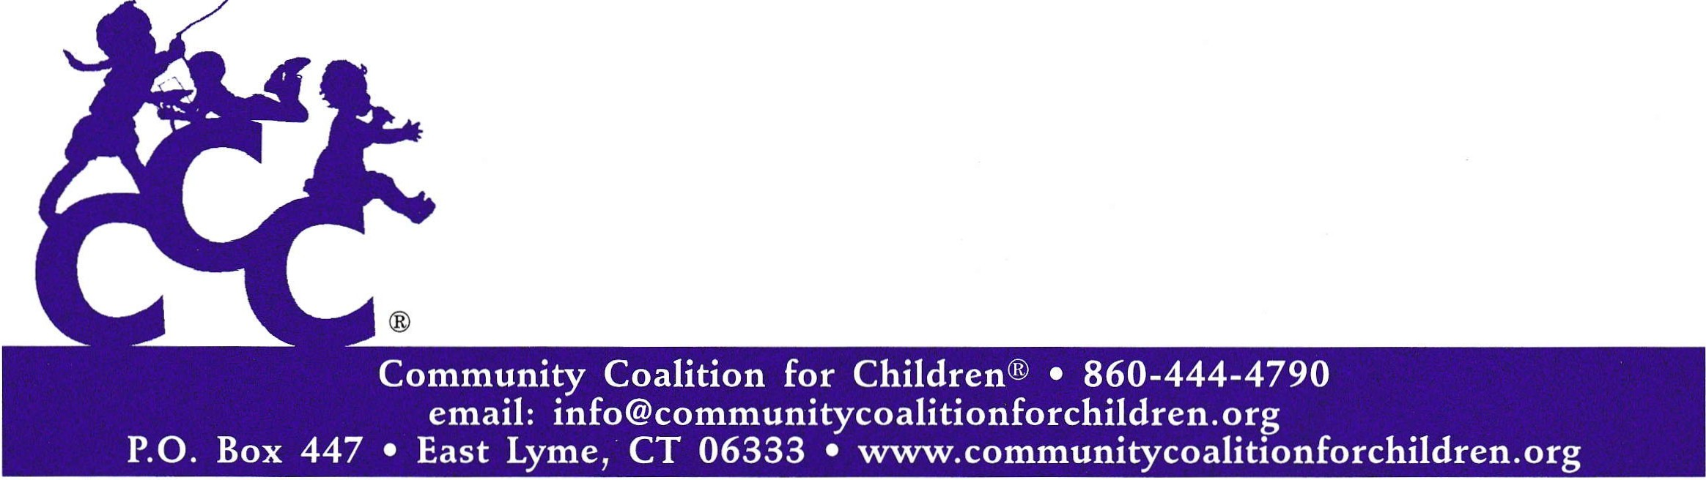
In order to stimulate ongoing action following the conference, the CCC has taken its 20th anniversary as an opportunity to establish a new initiative, the Catalyst Challenge Award. Intergenerational participants will be challenged to take what they have learned back to their own community or school, enabling students, parents, and child-centered professionals to bring about positive change in their community. The challenge requires participants to develop and implement practical strategies throughout the year to carry the conference message to their communities. In the spring of 2017, award winners will be announced and recognized at the Catalyst Award Ceremony attended by nominees, conference participants, and community members.

www.communitycoalitionforchildren.org

POC = Kathleen O’Beirne, PR Chair for Community Coalition for Children…helping children thrive® (860) 536-7179 or email: kathleenobeirne@aol.com

